C3-S4-PRACTICE

# What you will know:

LIKE - DISTINCT

Open [this online SQL editor](https://www.w3schools.com/mysql/trymysql.asp?filename=trysql_select_columns)

Look at the content of the **Customers** table, using a SQL command or by clicking on the link on the right side

**Q1**: Show all the **different** countries the customers comes from

Expected columns:

Country

**Your query:**

SELECT DISTINCT(Country) FROM Customers

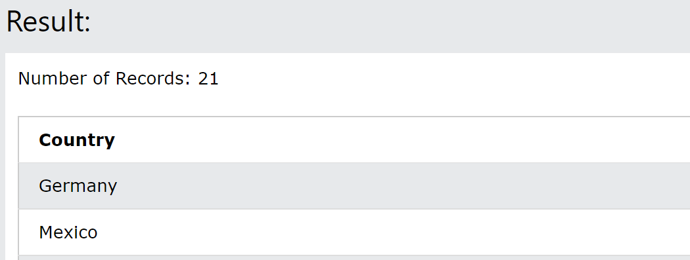

**Q2:** Show all the customers from Germany whose name starts with "D"

**Your query:**

SELECT CustomerName, Country FROM Customers

WHERE Country= "Germany" AND CustomerName LIKE "D%"

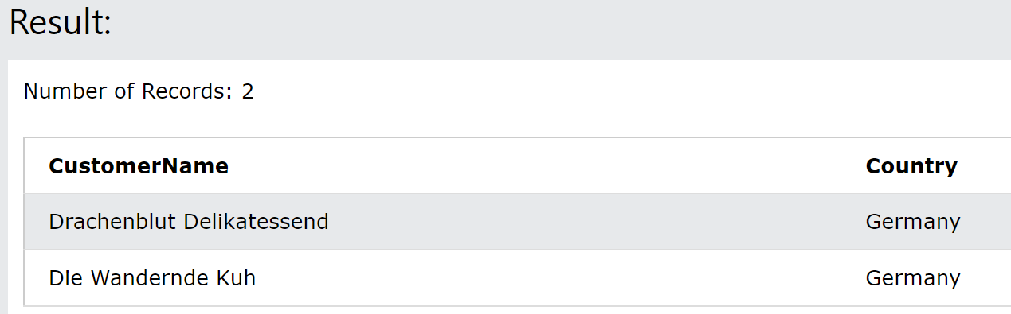

**Q3:** Show all customers from Germany whose name starts with "D", **together with** all customers from Mexico whose name **does not** start with "A"

**Your query:**

SELECT CustomerName,Country FROM Customers where Country in ("Germany") and

CustomerName like ("D%") or Country in ("Mexico") and CustomerName not like ("A%");

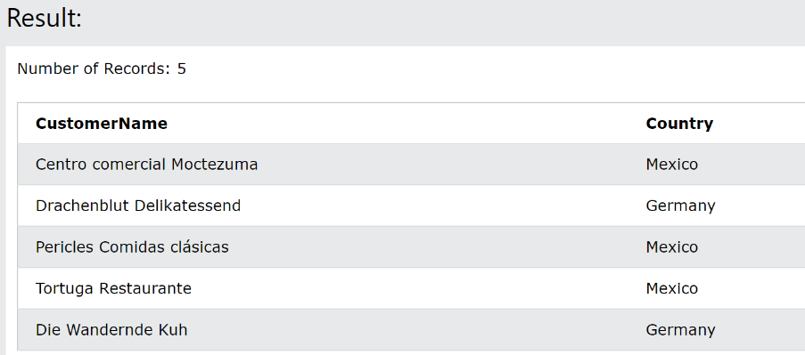

**Q4:** Show all customers from Germany whose id is before 40, together with all customers from Mexico whose id is greater than 50

**Your query:**

SELECT CustomerName,Country FROM Customers where Country in ("Germany")

and CustomerID < 40 or Country in ("Mexico") and CustomerID > 50;

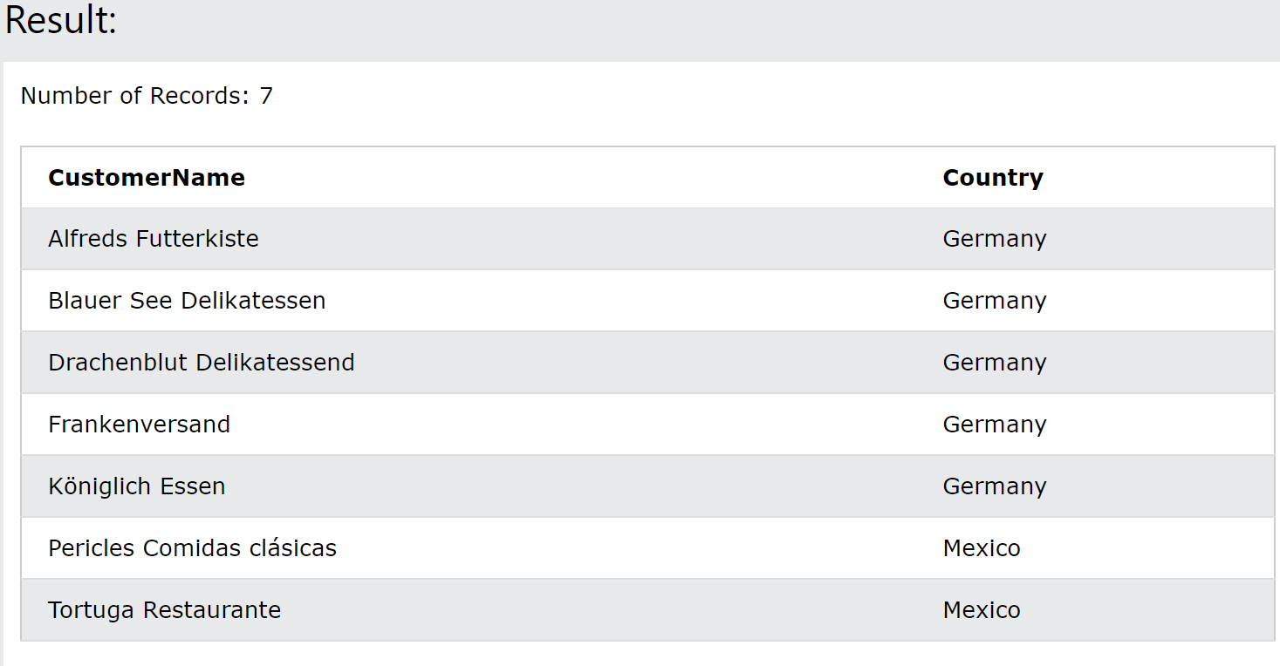

**Q5:** Show all customers from France whose name starts with ‘B’ together with customers from France who do not come from Paris

Note: Customer from France, coming from Paris and having a name starting with “B” shall appear only once on this result

Your SELECT CustomerName, City, Country FROM Customers where Country in

("France") and City not in ("Paris") and CustomerName like "B%" LIMIT 1;

Or

SELECT CustomerName, City, Country FROM Customers where Country in

("France") and City not in ("Paris") or Country in ("France") and CustomerName like "B%" LIMIT

1;

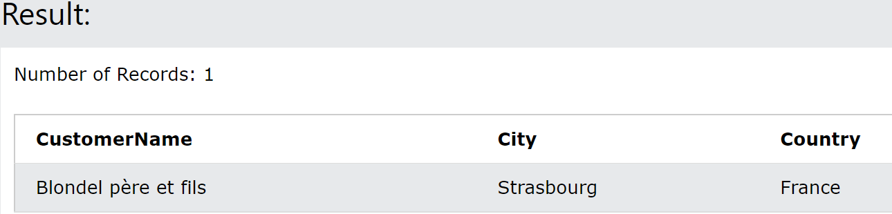

**Q7:** Display the different cities of customers from France or whose name starts with “B”

SELECT DISTINCT City FROM Customers where Country in ("France") OR

CustomerName LIKE "B%";

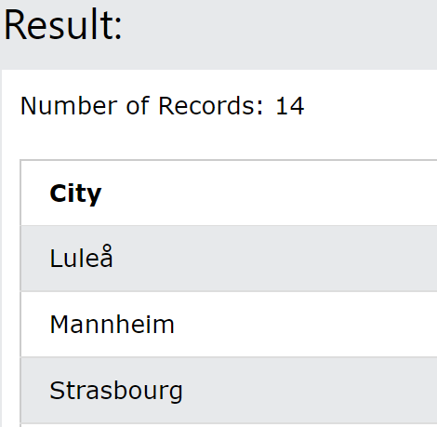

**Q8:** Display all customers who their start with letter s and end with letter e.

**Your query:**

SELECT CustomerName FROM Customers where CustomerName LIKE "S%e";

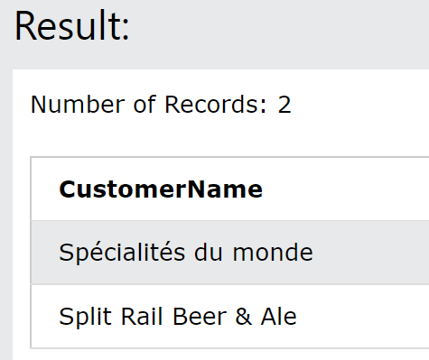

**Q9:** Display all customers who their names contain ‘er’

**Your query:**

SELECT CustomerName FROM Customers where CustomerName LIKE "%er**%";**

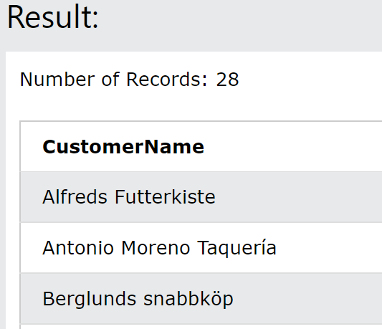

**Q10:** Display all product name that the second letter is ‘L’.

**Your query:**

SELECT ProductName FROM Products where ProductName LIKE "_L%";

